**September, 2016**

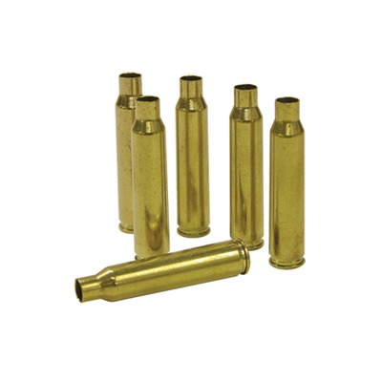

***ProBrass Inc.***

ProBrass, Inc., headquartered in

Manning, South Carolina, is an innovative manufacturer of

brass rifle cartridge cases.

Starboard Capital Partners was financial advisor

to the formation of ProBrass, Inc.

